Chapter 5, Problem 41

An averaging amplifier is a summer that provides an output equal to the average of the inputs. By using proper input and feedback resistor values, one can get
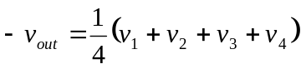

Using a feedback resistor of 10 kΩ, design an averaging amplifier with four inputs.

